**For sale:**

Takacat Tender T300S

Catamaran, Category C, 4 Persons, max 10 HP, max Load 380 kg

Year 2013, in use since 2015

With Overpressure Valve

More information’s: www.takacat.com

Only 300 Euro

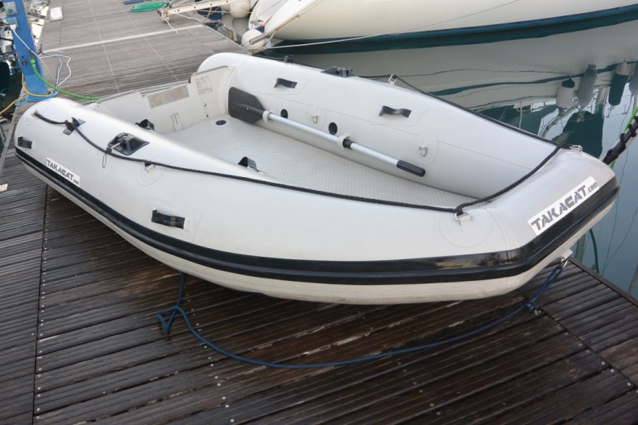

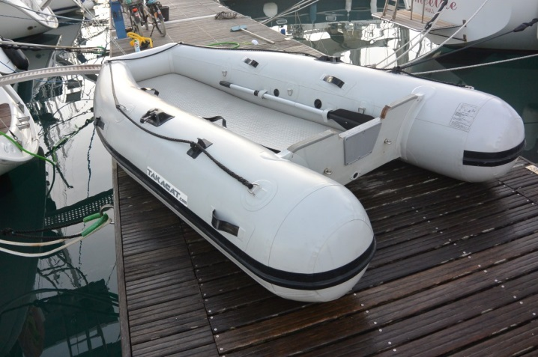 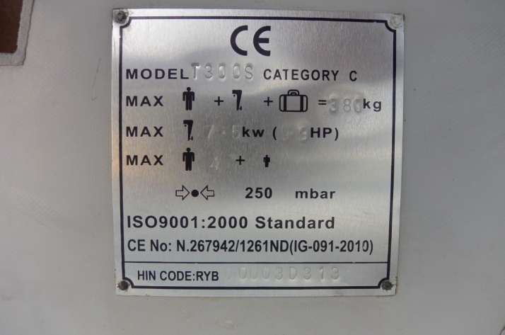

Contact

SY Easy-One

Gouvia Marina, Corfu

Ingo Mobile and Whatsapp 0049 176 4711 24 38 or Ingo.Veth@freenet.de